HQG Visit Date:
Farm/Facility:
Picker Name & Grower Number(s):
Grower Name & Phone:
Physical Address of Farm/Facility:
Email Address:
Picker Type(s) & Description:
Merchant Partners/Direct/Both?

HQG Attendee & Brewery
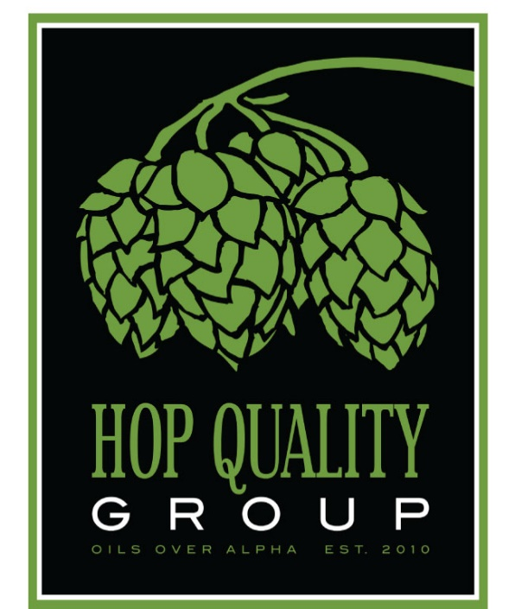

Operations Description:

Areas of Concern:

Improvements since last HQG visit (if applicable):

Recommendations:

Additional Comments:
What hop varieties are grown? Acreage?

Does Grower plan any major upgrades in the near future?

Does Grower operate multiple facilities? If yes, how many? Facility names and locations (grower numbers)?

Does Grower custom pick for anyone else? If yes, who?

What certifications does the grower possess, if any?

Additional Comments about the operation?

