HQG Visit Date:
Farm/Facility:
Picker Name & Grower Number(s):
Grower Name & Phone:
Physical Address of Farm/Facility:
Email Address:
Picker Type(s) & Description:
Merchant Partners/Direct/Both?

HQG Attendee & Brewery
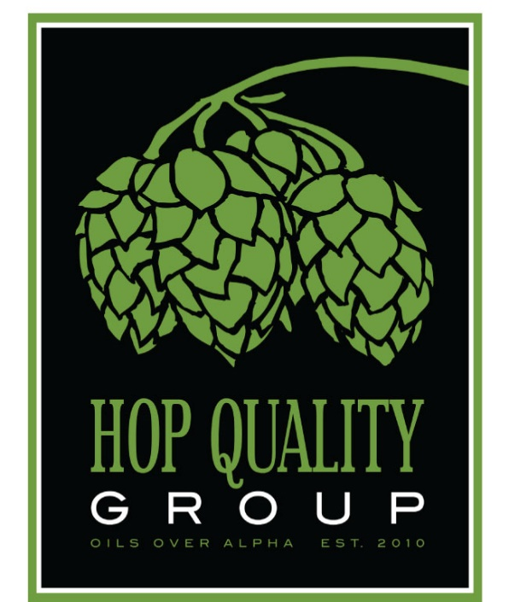

Operations Description:

Areas of Concern:

Improvements since last HQG visit (if applicable):

Recommendations:

Pellet Mill Checklist:
- Primary Owner/Operator:

- Manufacturer of Hammer Mill:

- Date of manufacture or installation:
- Motor Size in HP:
- Manufacturer of Pellet Mill:
- Date of manufacture or installation

- Manufacturer of Pellet Mill.
- Date of manufacture or installation?
- Motor size in KW or HP?

- Blending capacity.
- Bale breaker bin capacity?
- Powder tank capacity?
- Blender type (Ribbon or Conical)?

- Throughput capacity (per 24 hours):

- Magnet locations:

- Pellet diameter and number of die sizes owned:

- Target temperature of pellet and cooling method:

- Vacuum hard pack or soft pack?
- flush gas type?

- Quality Test performed:

- Laminate foil integrity tests performed and frequency of tests:

- Standard label information:

- Cold & Frozen storage capacity, if applicable:

- Any third-party certification:

