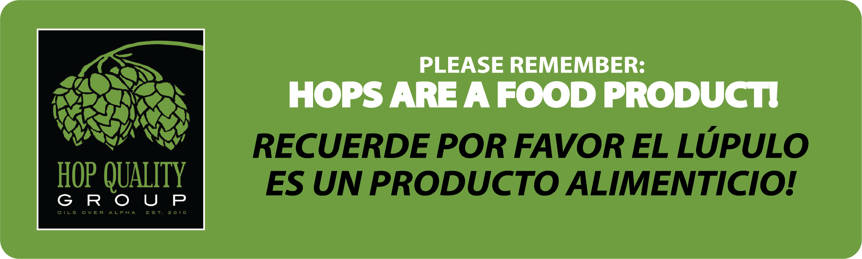
Hop Quality Group Grower Relations Facilities Visit SOP

Grower Relations Mission Statement:
The Grower Relations Committee focuses on cultivating mutually beneficial relationships among hop growers and craft brewers. The committee organizes communication and outreach between these brewers and growers, established and emerging, here and abroad. This connection from farm to pint encourages collaboration, drives innovation, and promotes excellence. This committee seeks shared success through the development and promotion of exciting and innovative varieties with mutual benefit. Through regular farm pre-harvest visits and subsequent reports available to the membership of the Hop Quality Group, this committee reminds growers of the importance of food safety during processing and shows our appreciation, as brewers, to that dedication

Pellet Mill Mission Statement:
The HQG Pellet Mill Committee engages with hop pellet processors to determine and ensure best practices with particular focus on food safety and consistent hop pellet Quality. The HQG Pellet team will work with established and emerging facilities through outreach and partnerships towards better understanding and meeting the needs of all stakeholders in hop pellet production. From bale receipt traceability to storage and distribution, the HQG will work to ensure the needs of Brewers are met by the processing practices of food safe facilities, purpose built for turning hop cones into high quality refined hop pellet products ready for Brewing

Hop Farm and Pellet Mill visit purpose:
Hop farms visits have been a consistent focus of HQG since our inception. HQG has initiated a new dialog about what is important for craft brewers as it relates to hops. Our goal is to ensure the messages around hop quality and food safety are aligned throughout the supply chain. Through written reports, the information is logged for reference on the membership page on the website. A copy is also provided to the farm. This information is for Hop Quality Group members only and is not to be shared publicly. See below for the Anti-trust rules. All members of the group are encouraged to participate.

Ambassadors:
Each hop growing region is assigned an Ambassador by the members of the Grower Relations Committee. This Ambassador oversees organizing and planning outreach within this region. If a member is interested in visiting, or has a connection at a specific farm, they should reach out to the area Ambassador, or raise their hand in the general meeting.

Domestic Pellet Mills: Alec Mull
Washington Farms: Jeremy Moynier
Oregon Farms: Daniel Sharp
Idaho Farms: Alec Mull
Michigan Farms: Alec Mull
New York Farms: Jeff O’Neil
European Farms/Pellet Mill: Matt Brynildson
New Zealand Farms/Pellet Mill: Jeremy Moynier
Australian Farms/Pellet Mill: Jeremy Moynier

Farm Visit Cadence
Specific farm visit frequency will be managed by area HQG Ambassadors. Historical farm visit data is managed by Executive Director, Tom Tweedy and published on Member Area of website. Frequency of visits should correlate to quality of farm conditions determined by visit feedback and follow a healthy cadence. Don’t visit the same farm every year if they are doing a good job! Be considerate of the Grower but also absolutely visit if requested!

Farm Visit Expectations:
- Adhere to the spirit of our Mission Statement, and HQG Code of Conduct
- Be a good Ambassador, professionalism is required.
- Adhere to vendor/grower rules (like ppe requirements, proper clothing, etc).
- Adhere to customs/culture of the area.
- Bring HQH “Hops are a Food Product!” signs written in languages specific to the growing region
  - It is up to the farm where they should be placed.
- Complete HQG reports and give vendor/growers feedback within two weeks of visit.
- Communicate to the vendor/grower ahead of time about report forms and the intention of the visit.
- Ensure that feedback is presented in a constructive manner. We aren’t the hop police, but working collaboratively to improve hop quality.
  - Approach is the key word. If you see something distressing, you should point it out, but constructive criticism, rather than a castigatory approach. Growers are proud (like Brewers), so it is always Important to be mindful of that.
- Group size should be small enough to encourage good dialog with the Grower, but also big enough to show proper interest and support from HQG. Generally, between four and nine people achieves this, with 2-3 veterans as well as a few new members to balance experience and new perspective. Larger groups can be accommodated by splitting up into smaller groups
- Traveling internationally: a stipend for travel expenses is available.
  - To receive the stipend, you must get approval from HQG E-Team PRIOR to the trip.
- It’s also good to bring beer and swag to give to the growers during visits (they are always super stoked). Whatever each member is comfortable bringing, for reference, (3–5 cases in 6-pack form is good) and whatever swag (shirts, hats, stickers, etc) as well. 2 cases per member brewery for each growing region BBQ is also greatly appreciated. Organizing beer/swag and shipping ahead of time will incorporate broader membership participation and support, especially for those who can’t attend in person.
Farm BBQ:
A BBQ is organized each year by the region’s Ambassador. This is a great place to bring the farmers together with the Brewers, and a cornerstone of developing a long-lasting relationship with the Growers. While the number of attendees is limited on the farm, it is encouraged to get as many members (and non-member Brewers) as possible to the BBQ event. A budget is in place to accommodate cost of the BBQs.

References:
Before you go, here are some helpful documents outlining what to pay attention to at the farm or Pellet Mill, as well as examples of the written report expectations.
Farm Sanitation Guideline
Food Safety: Best practices
Example of a completed HQG form
Blank Farm Report
Blank Pellet Mill Report

**HQG Anti-Trust**

This is the responsibility of all Hop Quality Group members.

Do not discuss any of the following topics:
- Prices, pricing procedures, margins, what constitutes a fair profit level, changes in or stabilization of prices, terms or conditions of sale.
- Pricing practices of any industry member, including whether such practices are unethical, unfair, or in compliance with applicable legal standards.
- Forecasts of price increases or decreases.
- Specific credit terms, discounts, rebates, freight allowances, profits, profit margins or costs, market shares, allocation of markets, any limitation on sales, sales territories or distribution practices.
- Production levels or schedules - or the regulation of same.
- Bids, or intent to bid, or not bid on a contract.
- Selection, rejection, boycott, refusal to deal with, or termination of any suppliers or customers.

Do not exchange price information (or other sensitive business information) with competitors.

Do not agree with any competitor to refuse to sell to certain customers, or to buy from certain suppliers.

Do not discuss anything that may in any way tend to affect the availability of products or services.

Do not foster practices involving advertising, merchandising, standardization, certification, or accreditation that may be perceived as misleading or as limiting competition or the ability of any industry member to compete.

Do not discuss matters that will encourage anyone to refrain from competing vigorously.

Do not discuss matters that will limit anyone from manufacture or sale.

Do not discuss matters that could result in illegal brokerage or rebates.

Do not discuss matters that could create improper reciprocity in dealing.

